**DAILY ONLINE ACTIVITIES SUMMARY**

|  |  |  |  |  |  |  |  |  |
| --- | --- | --- | --- | --- | --- | --- | --- | --- |
| **Date:** | **03/07/2020** | | | | | **Name:** | **SUJAYA** | |
| **Sem & Sec** | **IV sem & B section** | | | | | **USN:** | **4AL18CS090** | |
| **Online Test Summary** | | | | | | | | |
| **Subject** | | **-** | | | | | | |
| **Max. Marks** | | **30** | | **Score** | | | **-** | |
| **Certification Course Summary** | | | | | | | | |
| **Course** | **Introduction to Productive Modelling and Analytics** | | | | | | | |
| **Certificate Provider** | | | **Greatlearning academy** | | **Duration** | | | **5.5hours** |
| **Coding Challenges** | | | | | | | | |
| **Problem Statement1:** ------------------------ | | | | | | | | |
| **Status: --------------** | | | | | | | | |
| **Uploaded the report in Github** | | | | | **----------------** | | | |
| **If yes Repository name** | | | | | **------------------** | | | |
| **Uploaded the report in slack** | | | | | **--------------------** | | | |

Online Test Summary: No internals conducted today.

Online Certification Course Summary: Today I have opted the new course named Introduction to Productive Modelling and Analytics which belongs to Data Science Stream. In today’s session I have learnt what is Productive Modelling.

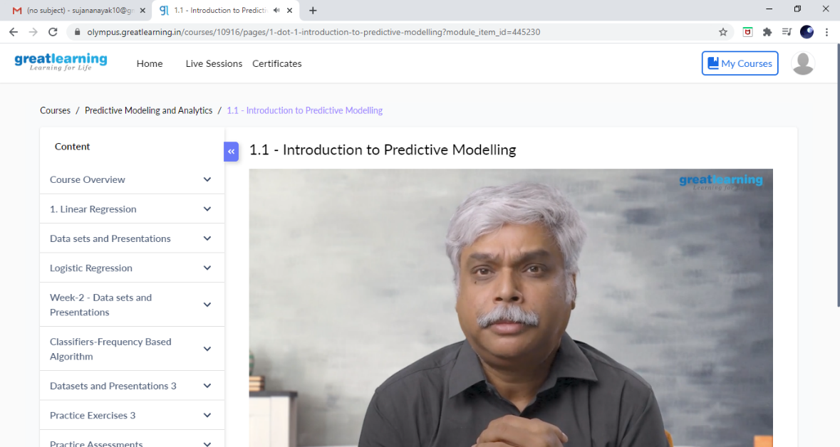

This is the Snapshot of today’s session.

Online Coding Summary: No problem Statements given.

Online Training: Today I had attended the online training organized by CSE Department AIET. The training was on C done by Prof.Megha Hegde. After the session the quiz was conducted.

